Lab Report

EXPERIMENT 01 Date: khali chordo/2/2024

Experiment Title : Familiarization with the Lab equipment
Measuring Resistors using DMM

Group Members:
Tariq Afridi F24604060
M.Hamzah Iqbal F24604018
Rohan Kumar F24604054

Theoretical Explanation:
A Digital Multimeter (DMM) is a tool used to measure voltage, current, and resistance in electrical circuits. It has two probes (red and black) and a display to show readings. The dial on the DMM is used to select the measurement type. To measure current, the DMM is connected in series so all the current flows through it.To measure voltage, the DMM is connected in parallel across the component to check the difference in electrical potential between two points.
Resistors limit the flow of electricity, and their values are identified using color coding, which helps determine resistance and tolerance Resistor color coding is important for quickly identifying resistance without extra tools, ensuring the correct resistor is used in a circuit.

Task 1
Sr No. | Colors | Nominal Value | Tolerance | Minimum Value | Maximum Value
1 | Red-Red-Black-Silver | 22 Ω | ±10% | 19.8Ω | 24.2Ω
2 | Blue-Gray-Black-Gold | 68Ω | ±5% | 64.6Ω | 71.4Ω
3 | Brown-Green-Brown-Gold | 150Ω | ±5% | 142.5Ω | 157.5Ω
4 | Orange-Orange-Brown-Silver | 330Ω | ±10% | 297Ω | 363Ω
5 | Green-Blue-Brown-Gold | 560Ω | ±5% | 532Ω | 588Ω
6 | Brown-Red-Red-Silver | 1.2kΩ | ±10% | 1.08kΩ | 1.32kΩ
7 | Red-Voilet-Red-Silver | 2.7kΩ | ±10% | 2.43kΩ | 2.97kΩ
8 | Gray-Red-Red-Gold | 8.2kΩ | ±5% | 7.79kΩ | 8.61kΩ
9 | Brown-Black-Orange-Gold | 10kΩ | ±5% | 9.5kΩ | 10.5kΩ
10 | Orange- Orange- Orange-Silver | 33kΩ | ±10% | 29.7kΩ | 36.3kΩ
11 | Blue-Gray-Yellow-None | 680kΩ | ±20% | 544kΩ | 816kΩ
12 | Green-Black-Green-Silver | 5MΩ | ±10% | 4.5MΩ | 5.5MΩ

Procedure
Step 1: Identify the Color Bands and Their Values
Each resistor has four color bands, and each band has a meaning
Step 2: Find the Nominal Value (Resistance in Ohms Ω)
- The first two bands (Red-Red) represent two digits: 22.
- The third band (Black) tells us to multiply by 1.
- So, the Nominal Value of the resistor is:
22×1=22Ω
Thus, the Nominal Value = 22Ω.
Step 3: Find the Tolerance (Accuracy of the Resistor)
- The fourth band (Silver) represents a ±10% tolerance.
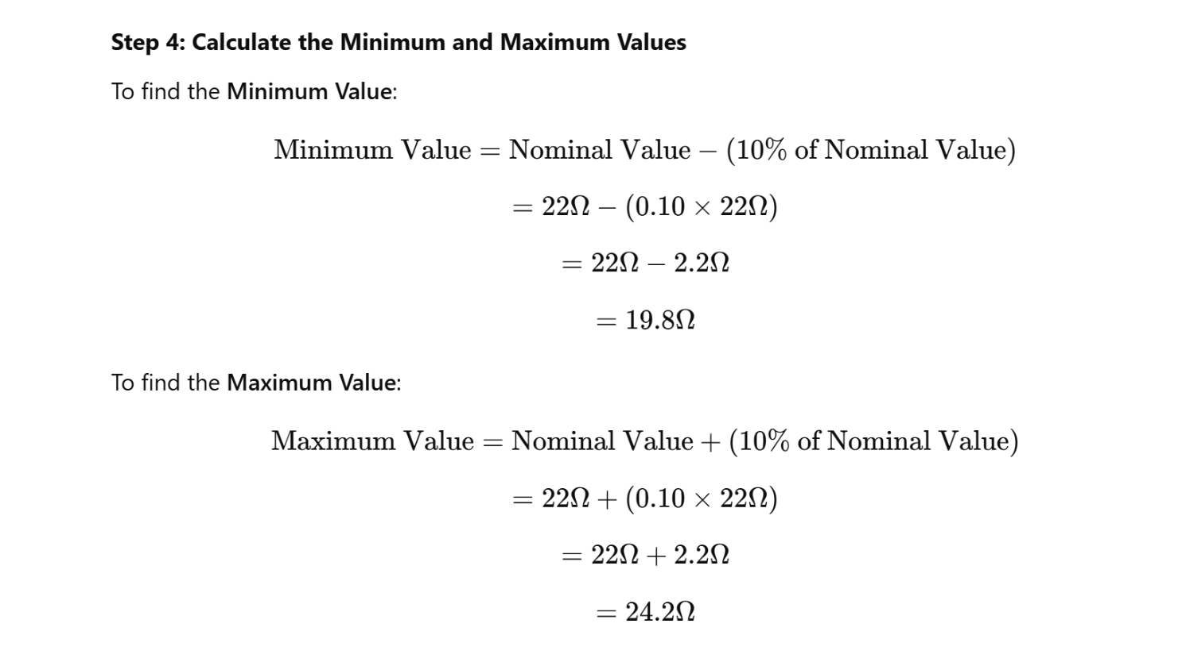
- This means the actual resistance can be 10% more or less than the nominal value.

Sr No. | Value | Band 1 | Band 2 | Band 3 | Band 4 | Band 5
1 | 27±10% | Red | Violet | Black | Silver | None
2 | 56 ± 10% | Green | Blue | Black | Silver | None
3 | 180 ± 5% | Brown | Grey | Brown | Gold | None
4 | 390 ± 10% | Orange | White | Brown | Silver | None
5 | 680 ± 5% | Blue | Grey | Brown | Gold | None
6 | 1.5𝑘 ± 20% | Brown | Green | Red | None | None
7 | 3.6𝑘 ± 10% | Orange | Blue | Red | Silver | None
8 | 7.5𝑘 ± 5% | Violet | Green | Red | Gold | None
9 | 10𝑘 ± 5% | Brown | Black | Orange | Gold | None
10 | 47𝑘 ± 10% | Yellow | Violet | Orange | Silver | None
11 | 820𝑘 ± 10% | Grey | Red | Yellow | Silver | None
12 | 2.2𝑀 ± 20% | Red | Red | Green | None | None
Task 2

Procedure
- Identify the first two digits:
The first digit is 2 → Red
The second digit is 7 → Violet
- Find the multiplier:
Since 27 is a two-digit number, the multiplier is 1 (10⁰) → Black
- Determine the tolerance:
Given tolerance is ±10%, which corresponds to Silver
- Fill the values in the table:
Band 1: Red (2)
Band 2: Violet (7)
Band 3: Black (×1 multiplier)
Band 4: Silver (±10% tolerance)

Analysis
The resistor values calculated using color coding match closely with the measured values using a digital multimeter (DMM). The tolerance percentage explains slight variations in resistance. This method ensures quick identification of resistor values without needing direct measurement, making it essential for circuit design.

Learning Outcomes
- Identifying Resistors Quickly: Learning resistor color coding allows quick identification of resistance values without measuring, similar to how grocery barcodes help in pricing items instantly.
- Using a Digital Multimeter (DMM): Measuring voltage, current, and resistance using a DMM is like a doctor using medical instruments (e.g., thermometer, blood pressure monitor) to check a patient’s health.
- Ensuring Circuit Safety: Correctly identifying and using resistors prevents overheating and damage, just like installing the right fuse in an electrical system to prevent short circuits.
- Understanding Tolerance in Resistors: Knowing tolerance helps select suitable resistors for circuits, similar to choosing a car tire with the correct pressure range to ensure safe driving.
- Practical Troubleshooting Skills: Measuring resistance with a DMM helps diagnose faulty resistors, just as a mechanic tests battery voltage to check if a car starts properly.

Conclusion
This experiment provided hands-on experience in resistor identification and measurement using color coding and a digital multimeter. Understanding these concepts ensures accurate circuit design, proper component selection, and effective troubleshooting in real-world applications.

